Car Rental Management System

Ronnel Brent D. Brutas

DCET 2-1

This programs aims to lessen paper works and to give a lot more easier process on renting a car. On launching or installing this project kindly download the .exe file and launch it and it automatically opens the program. At the first page, it will welcome you while loading and then you’ll be directed to the main menu of the program.

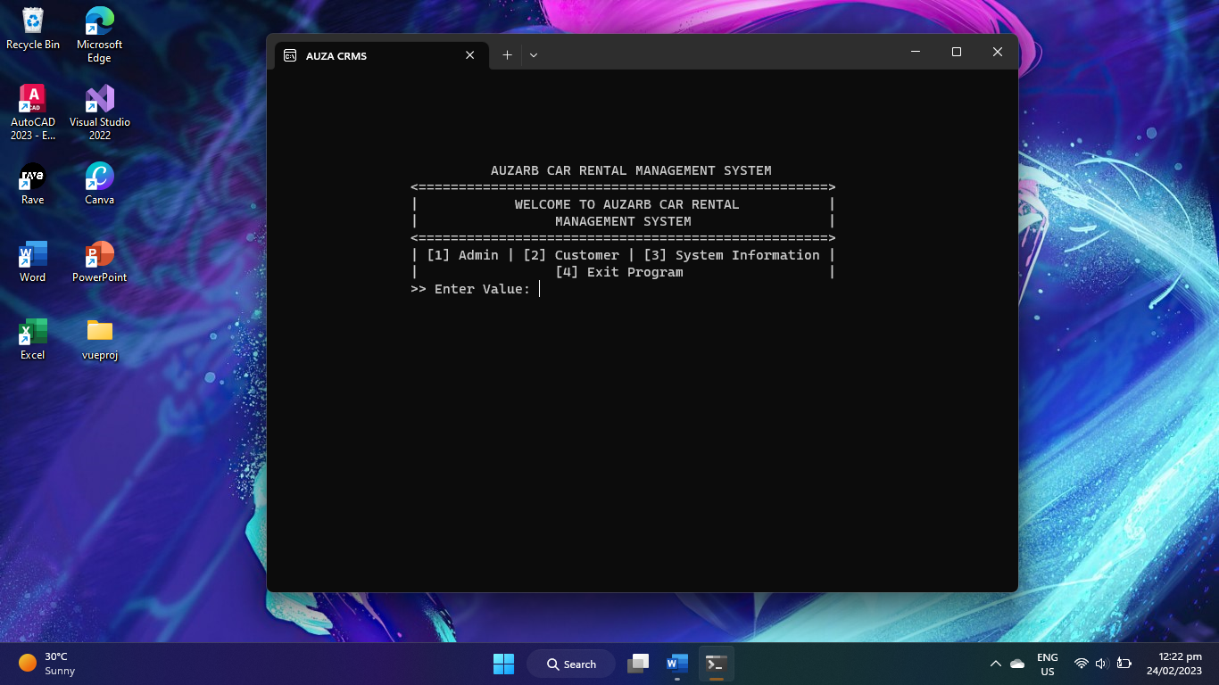

You will have an 4 option, it’s either the 1st, the admin if you’re an administrator, 2nd customer which is for customers and 3rd is system information where the mission or goal of the program and details are indicated and lastly the 4th option that will terminate the program and let you leave the system.

1. **ADMINISTRATOR PAGE**

When you’re an administrator, you choose the 1st option and you’ll be ask for a default username and password.

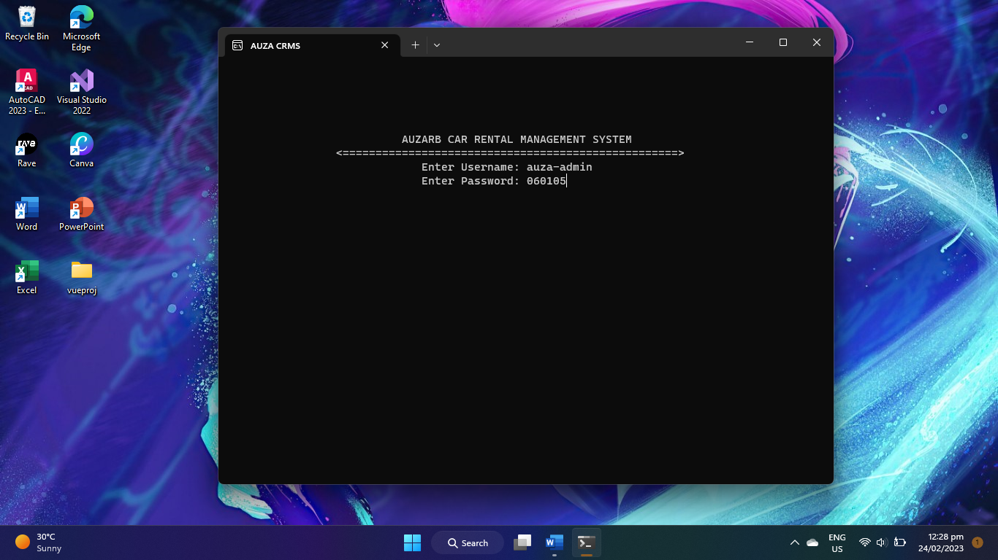

This is the default username and password of the administrator page. After you enter that correctly you’ll be redirected to the admin menu where you can create or add new car, edit, delete and view an existing car that’s on the list.

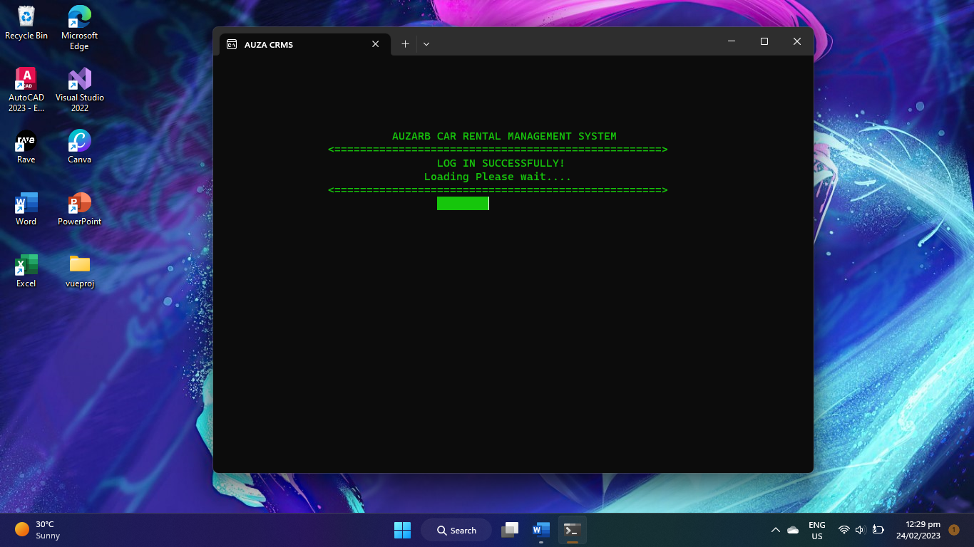

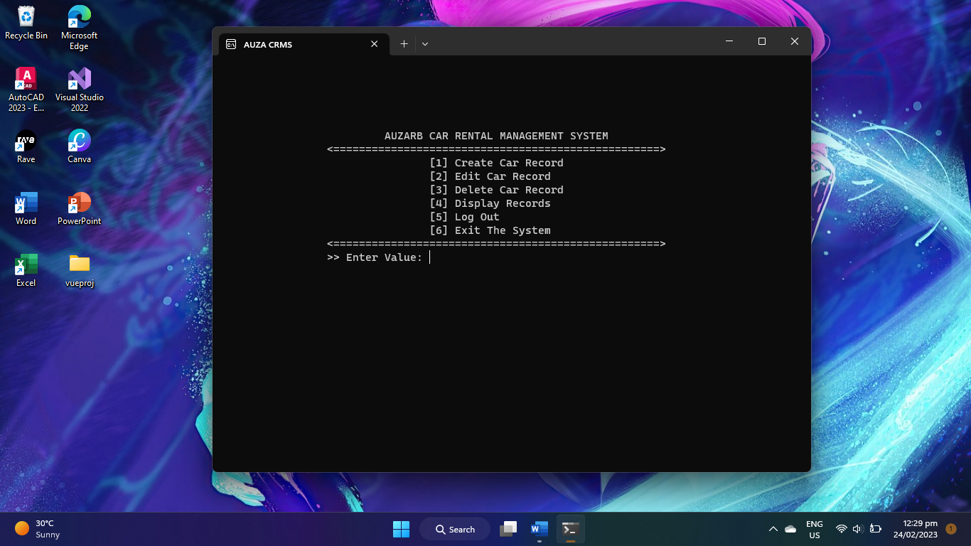

But if you entered the incorrect password and username, you’ll be redirected again on the log in page and will let you try again. This page will come out when you input incorrect username and password.

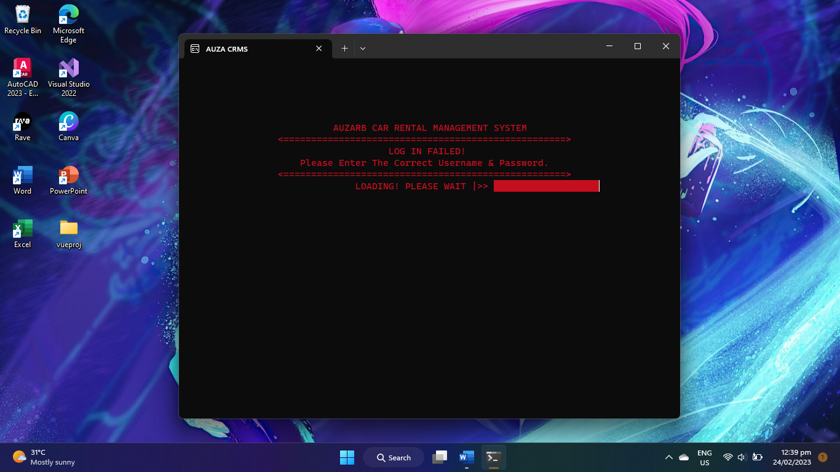

>Create Function

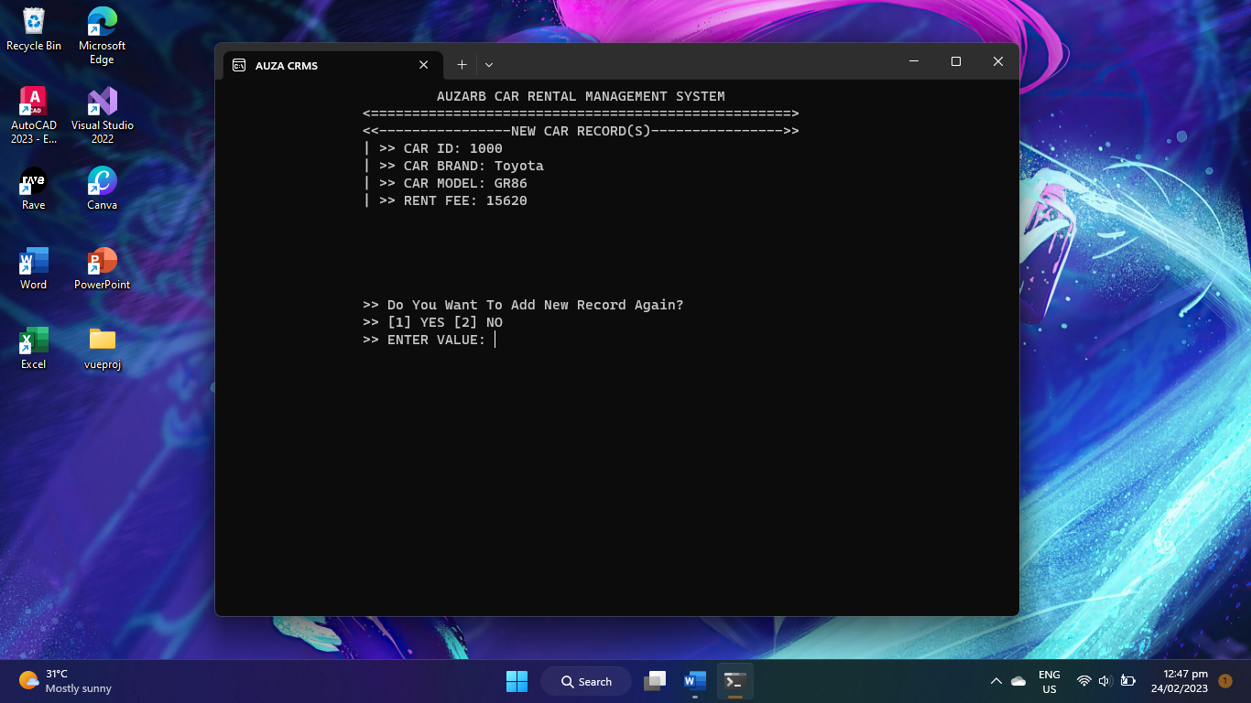

In this function, the create function will allow you to add new car, this are the list of details that will be ask to you and also when you’re done inserting one record you’ll be ask if you want to add more or not.

>Edit Function

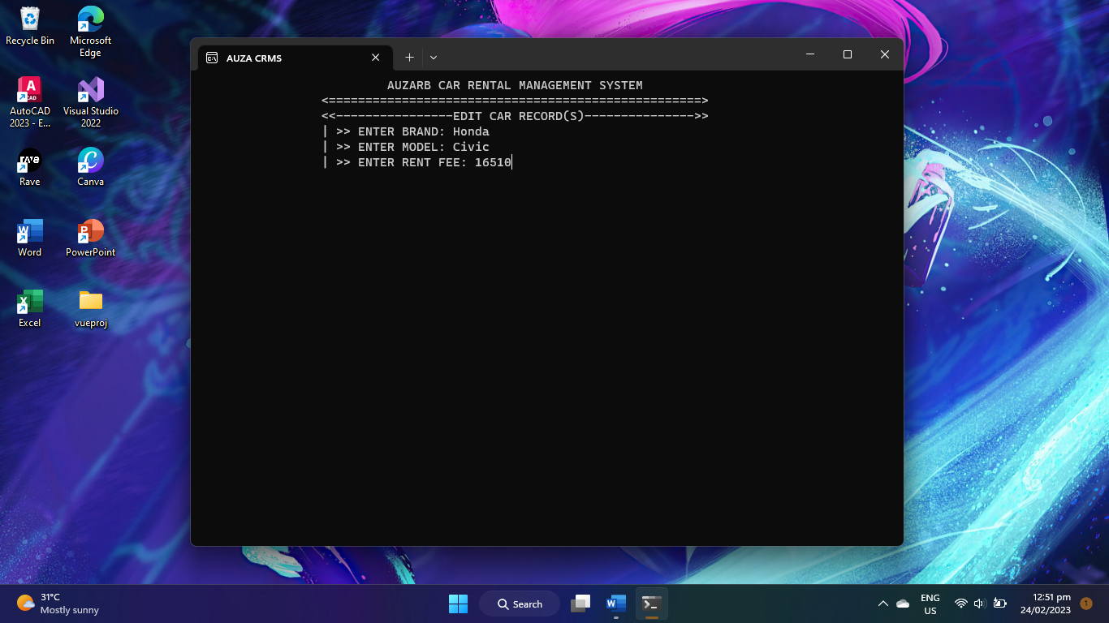

In edit function, first you will be ask to enter the Car’s ID that you want to edit and you’ll be now able to edit it’s details. When the ID you entered is unknown, the system will say “No Car ID Found’ and you’ll be redirected again to the admin menu. While when you entered an existing ID and done on entering the data you wanted to put, you will also be redirected to the admin menu.

>Delete Function

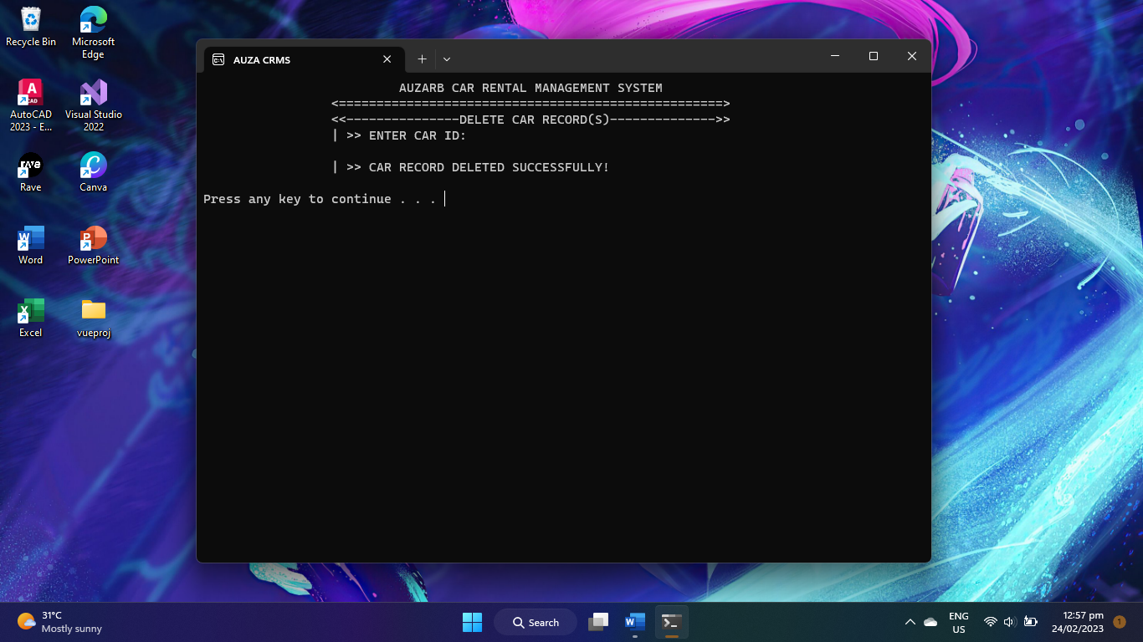

On delete function, the user will be ask for the Car’s ID again that he wants to delete.

>**View or Display Function**

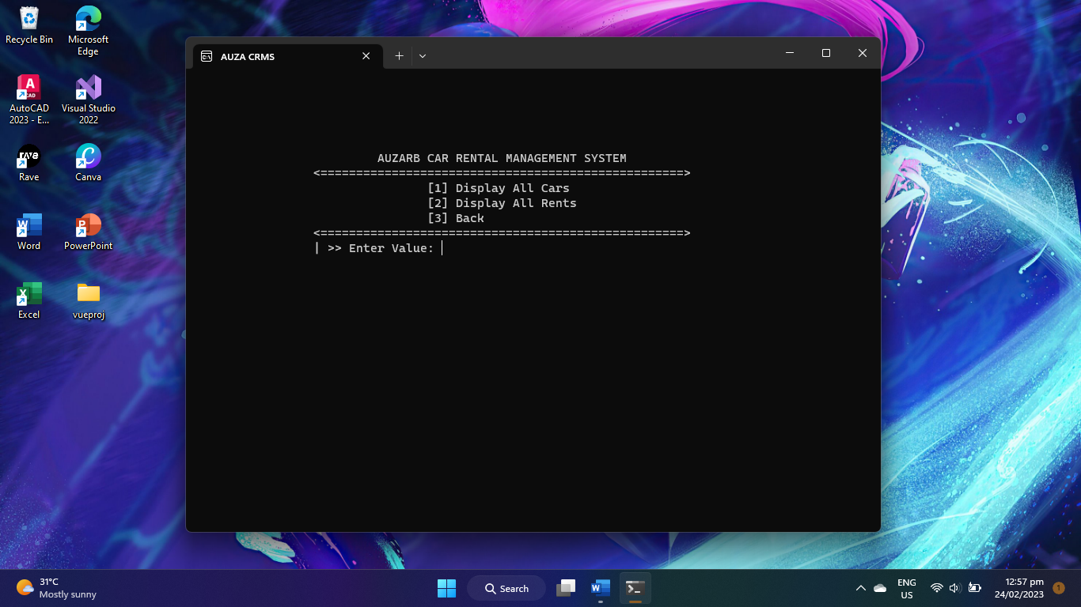

You’ll be directed and will be given another option, whether you want to view all the cars or view all the rent records.

-**View All Cars**

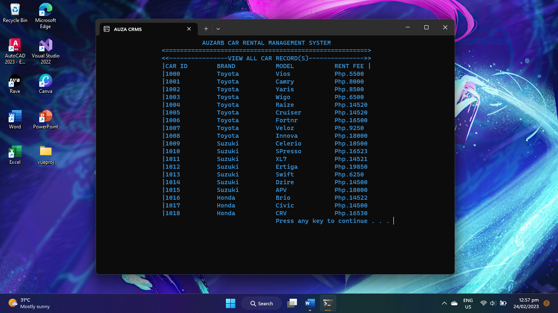

**-View all the Current and past records of car rented**

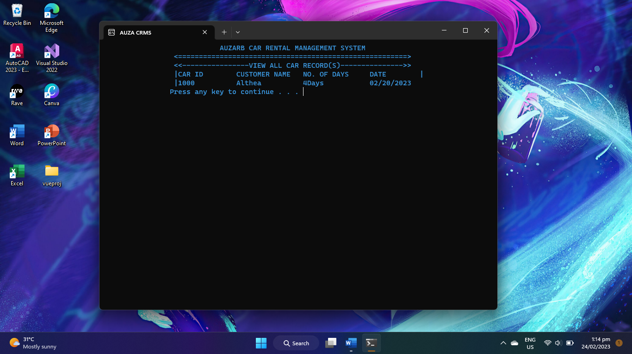

**>logout & exit**

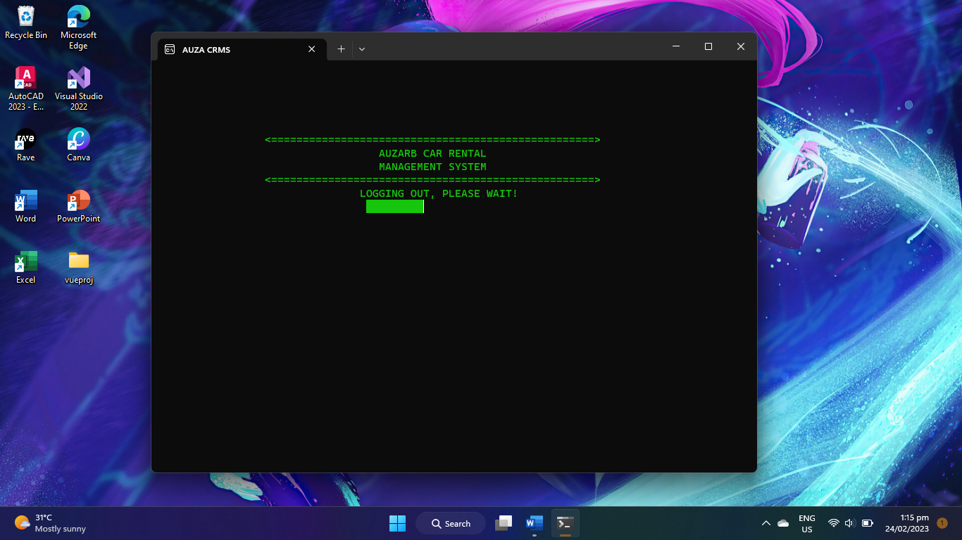

The log out and exit function are almost the same, the only difference is when you choose the log out command you will be directed again to the main menu, while when you choose the exit, you’ll exit the system or the program

1. **Customer Page**

This page is not protected by the password so that everyone can use it. When you enter the customer page, this are the option you’ll be choosing from. You are able to search, view and rent cars on your own

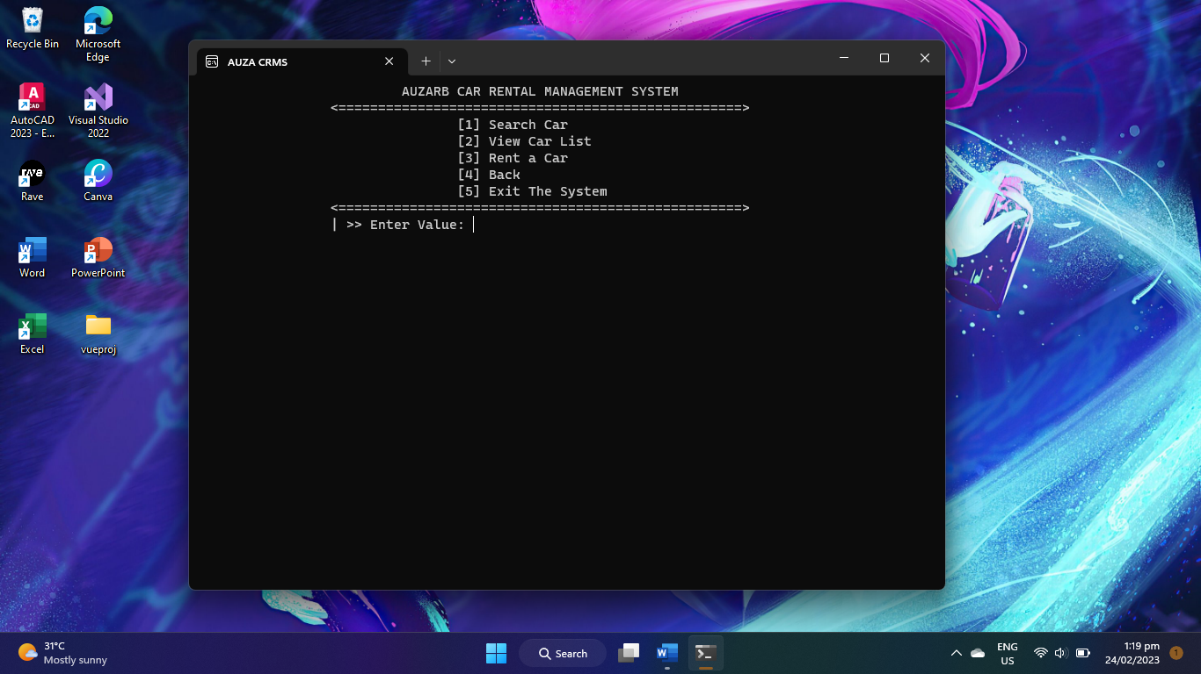

>**Search Function**

In this function, you will have another option whether you= want to search by brand, ID or model.

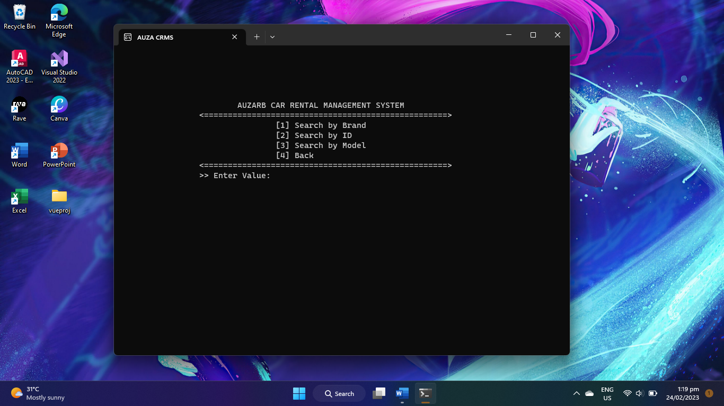

>**View Function**

This function Is similar to the one that’s on the administrator page. You are able to see the list of the Cars

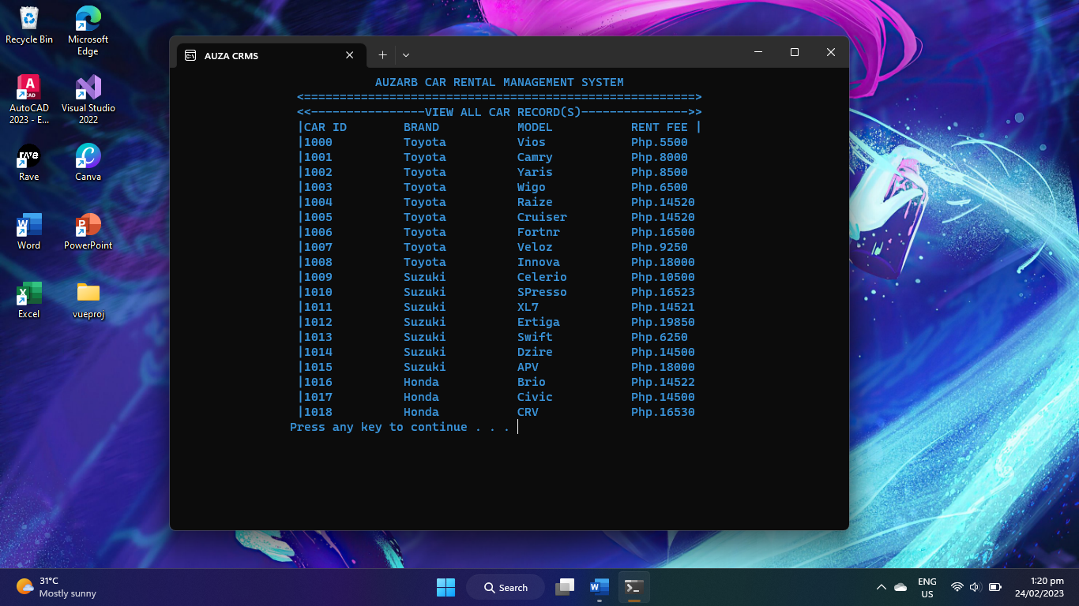

>**Rent Function**

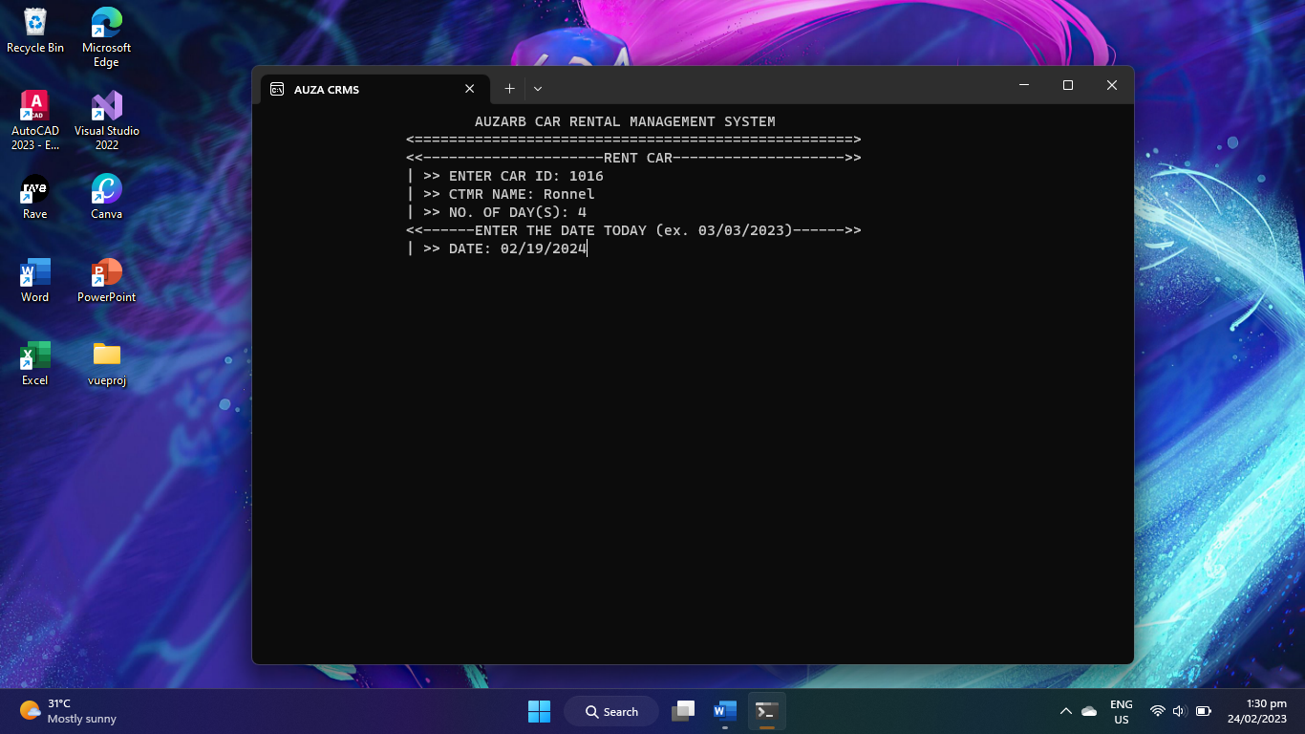

In this function you will now going to rent a car and the following details will be required like Ca’s ID of the car you got and some other personal information.

1. **System Information Page**

In this page, the mission or goal of this program are showed and also some details about the developer and the project manager.

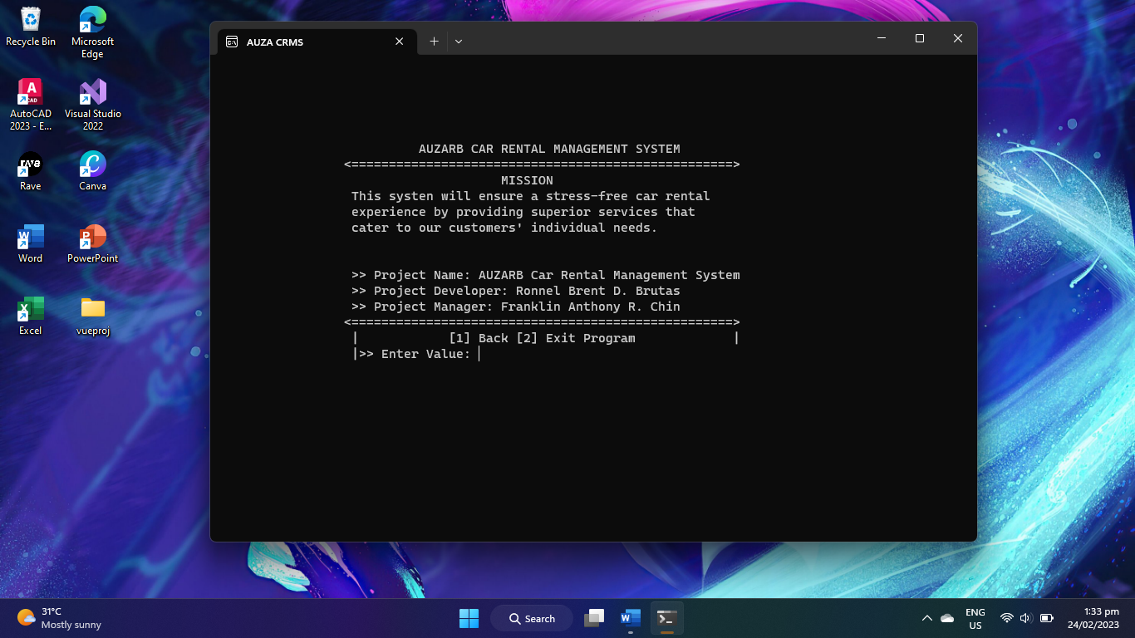

That’s all, thank you!